Work the following problems:

1. Convert the following Infix Notation expression to its equivalent Reverse Polish Notation (RPN) form.

5x2 – 3x + 7 = y2 *(Hint: reconfigure equality such that it equals 0)*

1. Convert the following Infix Notation Expression to its equivalent Polish Notation form.

{[(2 – x) + 3]2 – 10} * 2

*(note x here is a variable; * is the multiplication operation)*

1. Evaluate the following RPN expressions:
   1. 2 3 * 2 ^ 3 + 13 /

*(note, ^ is the power exponential function; / is the division operation)*

* 1. 3 3 ^ 9 / 5 + 4 / 2 –

1. For the expression given in 2 above convert it to its equivalent RPN form.
2. You are given the following elements from an adjacency matrix: n12 = 1, n22 = 1, n14, n21, n33 = 1, n41 = 1, and n23 = 1, n55. Draw the equivalent directed graph.
3. Given the above graph in exercise 5, what it the degree of node 1?
4. Answer the following questions given the Tree in Figure 1.

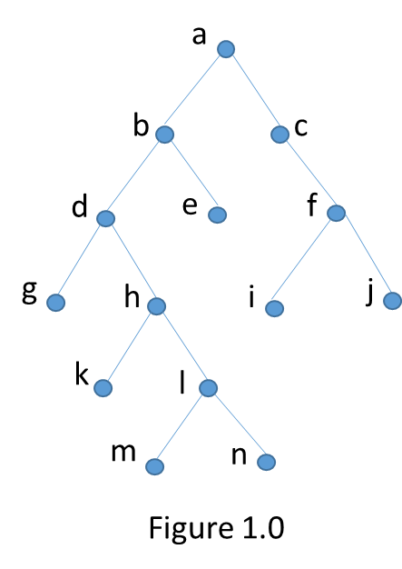

* 1. What is the height of the tree? _______
  2. What is the depth of node *h* _______
  3. How many leaves does the tree have? _______
  4. How many internal nodes does the tree have? ______
  5. How many children does node *e* have? ______
  6. Is the tree a binary tree? ______
  7. Is the tree a full binary tree? ______

1. A complete graph is when any two nodes are adjacent. What does this mean with respect to a node and all other nodes?
2. Are the following graphs in Figure 2 isomorphic graphs? ______

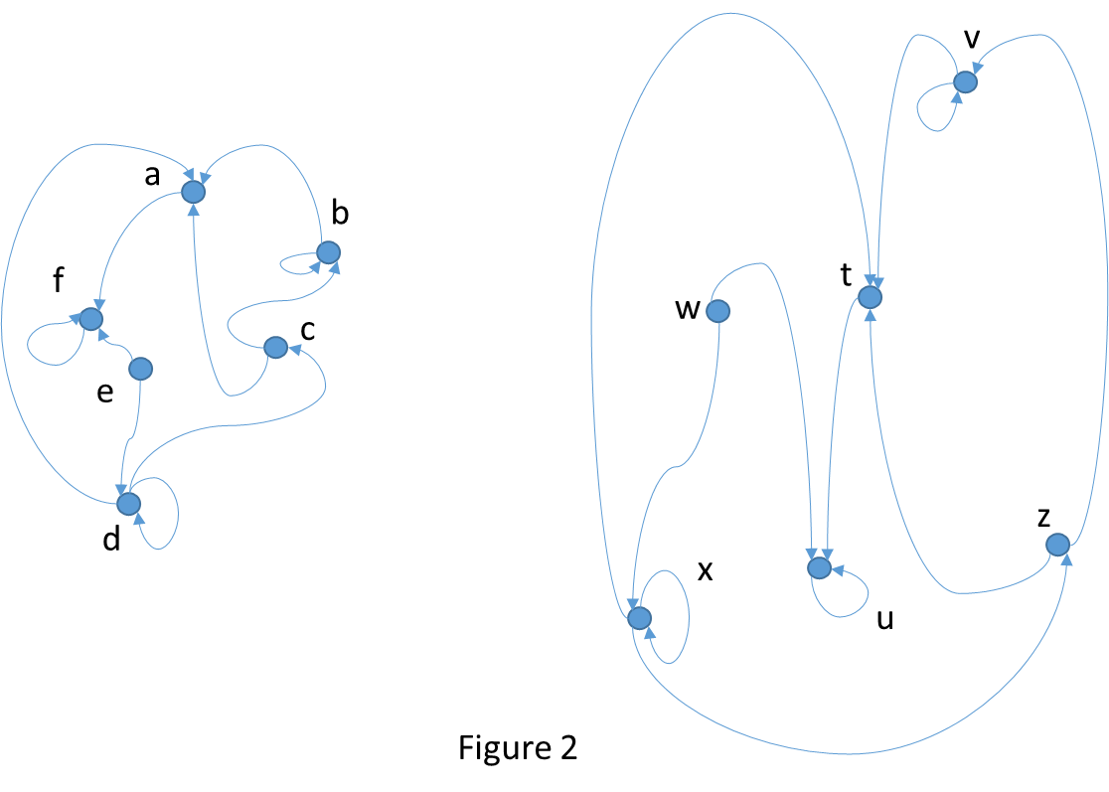

1. Is/are the graphs in Problem 9 planar graph(s)? If so – why?